|  |
| --- |
| Kantine; Produktbeskrivelse |

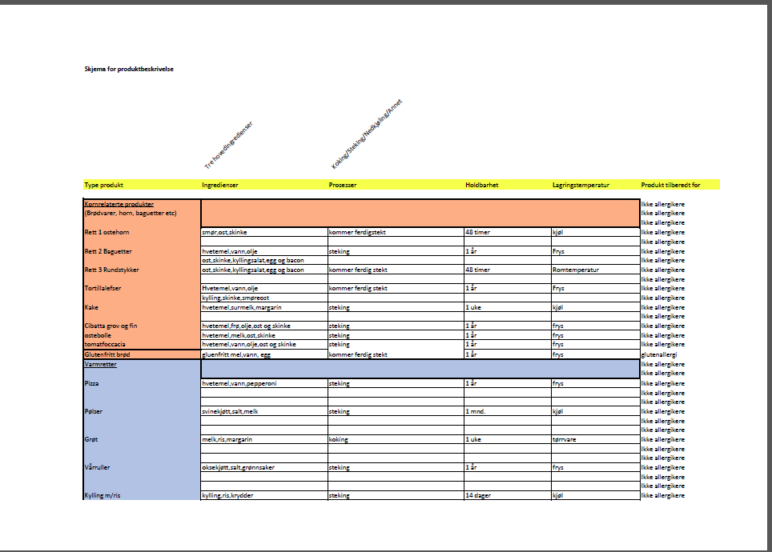

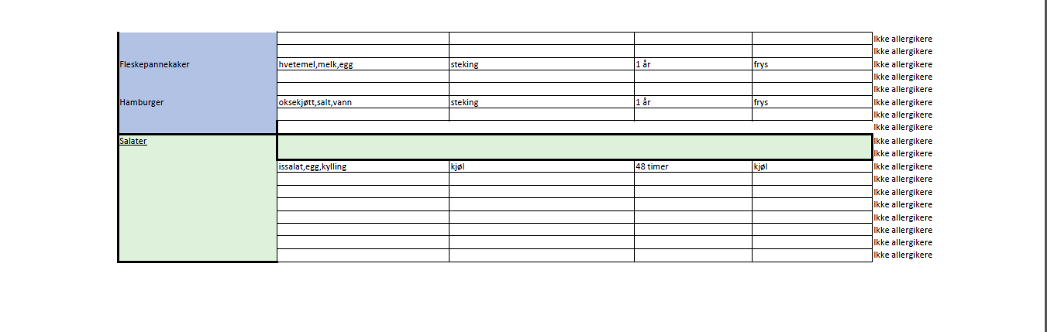

Kryssreferanser

|  |  |
| --- | --- |
|  |  |

Eksterne referanser

|  |
| --- |
|  |